**FLAPPY BIRD GAME IN JAVA**

A

Project Report

submitted

in partial fulfilment

for the award of the Degree of

**Bachelor of Technology**

in **Department of Computer Science and Engineering**

Logo of Manipal University

Project Mentor: Submitted By :

Name: Mr. Mayank Kumar Jain Ashnuta Upadhyaya

Designation: Assistant Professor 219301432

Department of Computer Science and Engineering

Manipal University, Jaipur

Session 2022-23

**Problem Statement and Objective**

To use various Topics in Object Oriented Programming in Java such as Inheritance, Abstraction, overriding etc. and create a project.

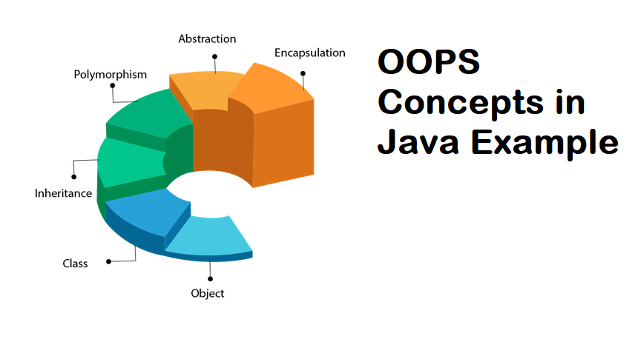

**Literature Survey /Market Survey/Investigation and Analysis**

The best way to learn a practical skill is by doing, and this is the reason why I was keen on choosing a game for my project. It has real life applications and has already been a successful and popular game amongst the people.

**Introduction to Project**

The project is based on the concepts of Object-Oriented Programming in Java.

It is a simple arcade game of Flappy Bird game and has been coded using the concepts of Object Oriented programming in java and other concepts in java programming language. The game development in java provides a practical application of the concepts learnt in the lectures and fulfils the requirements of the task given successfully.

The project also uses some swing components to make it look astonishing.

**Scope of the Project**

The project has helped me to learn various things in java that were unknown to me before. Game development already is a greater scope domain and this project is a great example for the practical applications of the concepts of Object Oriented Programming in Java.



**Methodology**

**Overall Description**

The project wouldn’t be successfully completed without the mentorship of Mayank Sir. Along with the topics taught in OOP there were few new concepts that were required to be performed and the main aim was to try and understand them and apply them correctly in order to build the project.

The bird is represented as a red square and the pipes are green rectangles.  Along with this the background is also created using fillRect and setRect functions. The motion and speed of the bird is included in the game loop along with the continuous movements of the pipe. And finally at the end the user interface has been added.

**User Interfaces**

The user interface aspect is properly fulfilled in my project. As it is a game it requires interactive user interface and for that MouseListener and KeyListener are the main feature that I tried to include in the project to make the game work.

The user may use the mousepad or mouse or the keyboard to make the bird jump

Flappy Bird is an endless game that involves a bird that the player can control. The player must save the bird from colliding with the hurdles like pipes. Each time the bird passes through the pipes, the score is incremented by 1. The game ends when the bird collides with the pipes or falls due to gravity. The sections below describe the steps that must be taken for building this game.

**FLOW DIAGRAM**

If bird jumps properly in between the pipes

**STOP**

Flash Game Over! In the screen and start again

Continue the game

Game loop for the bird jump and continuous pipe movement. Setting the speed of the bird

**START**

Creation of the frame using jframe in Java

**Constraints**

The aim is to fly through gaps in columns that are at the top and bottom of the screen. When you hit a column, the **game** is over.

**System Architecture**

The framework of the game is simply coded in java and tries to inculcate major features of object-oriented programming.

The game is a **side-scroller** where the player controls a bird, attempting to fly between rows of green pipes without coming into contact them.

**Future Scope**

This simpler version of of the game can be further uplifted by UI or adding different features such as medals or high scores. This in turn helps us to learn a variety of things and practically implement them into such projects.

**Conclusion**

Thus, this project shows the practical applications of Object-Oriented Programming in java and also makes use of the swing component of java to make the game more aesthetic and real.

* Eclipse IDE was used to build and complete the project.

**CERTIFICATE**

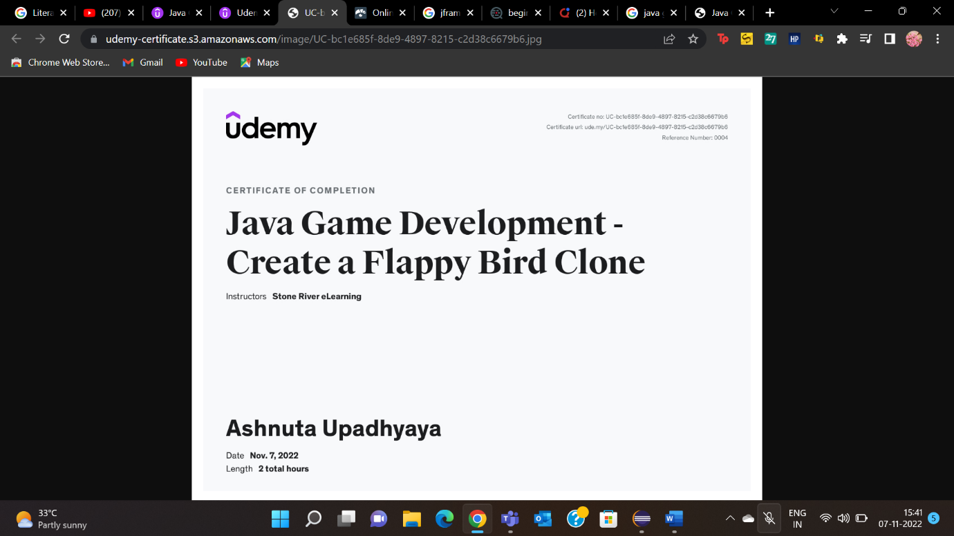

1.

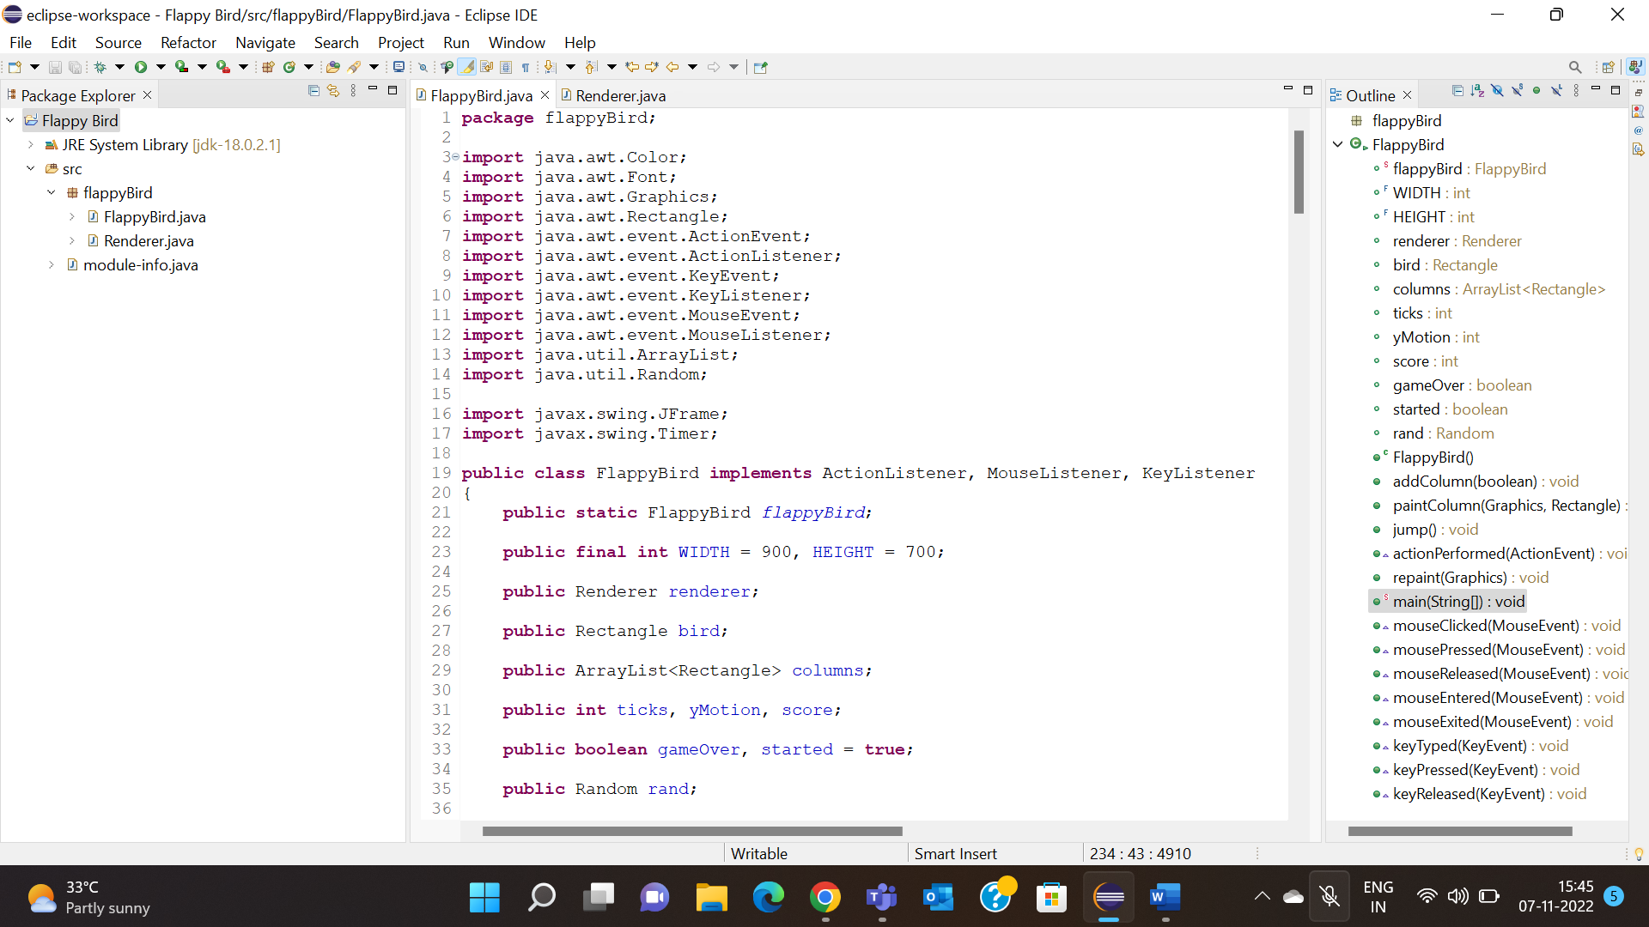

2.

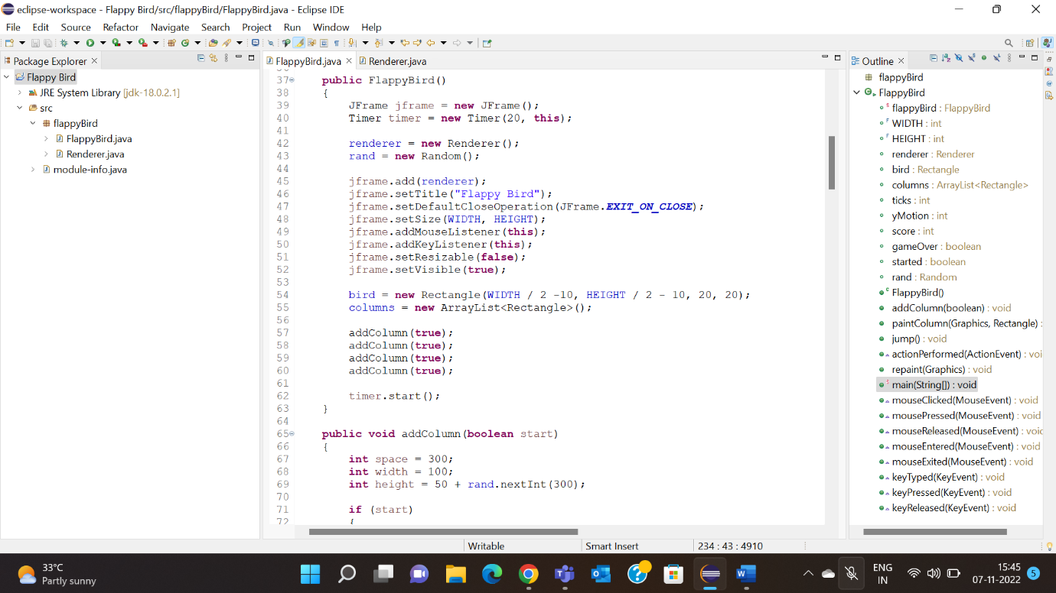

3.

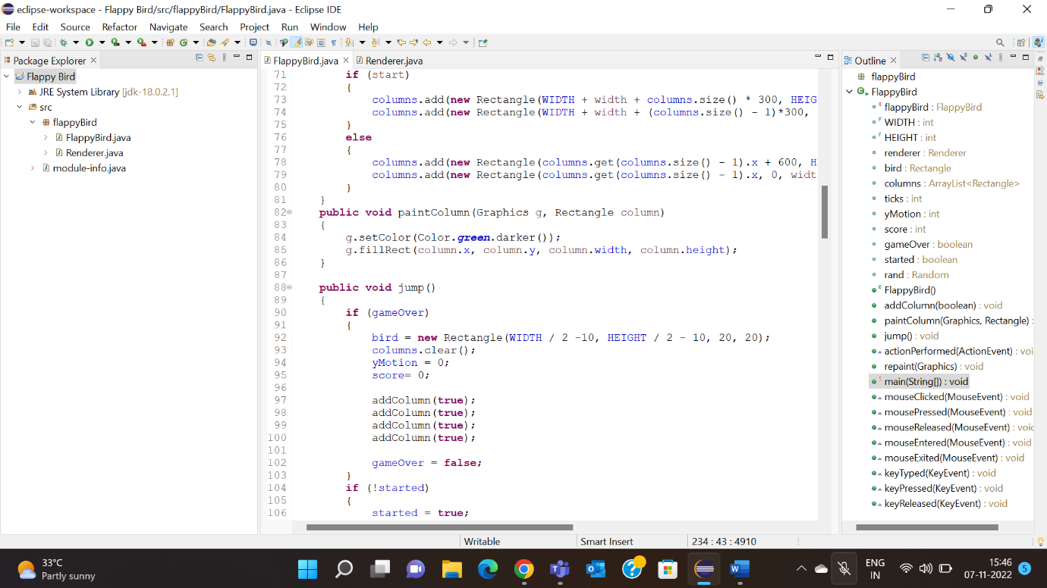

4.

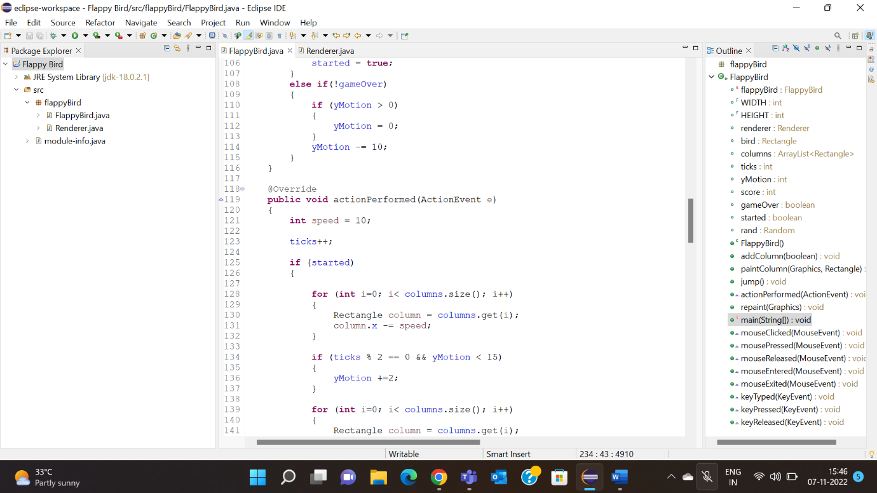

5.

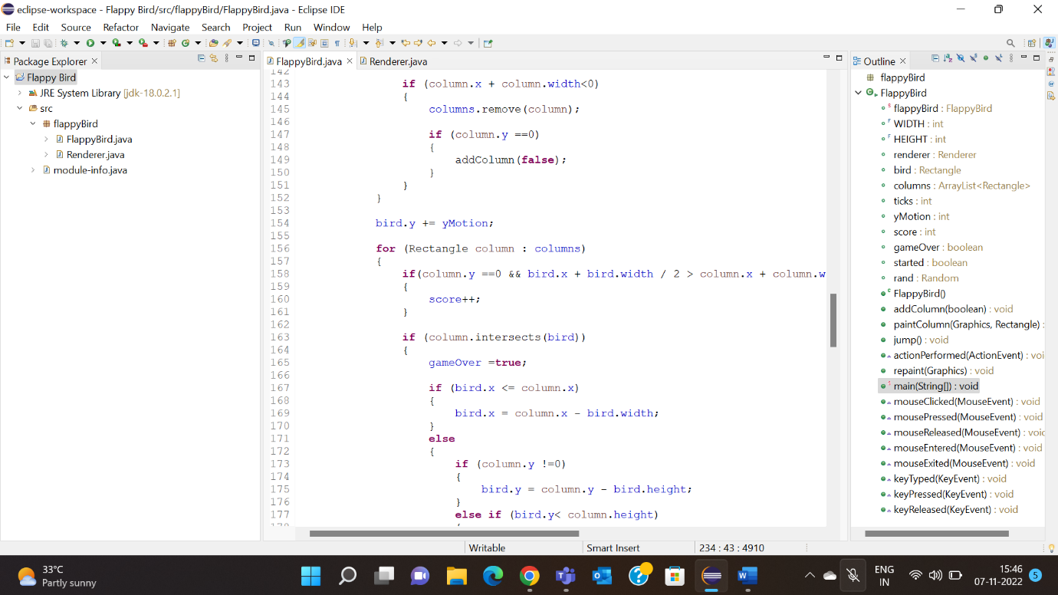

6.

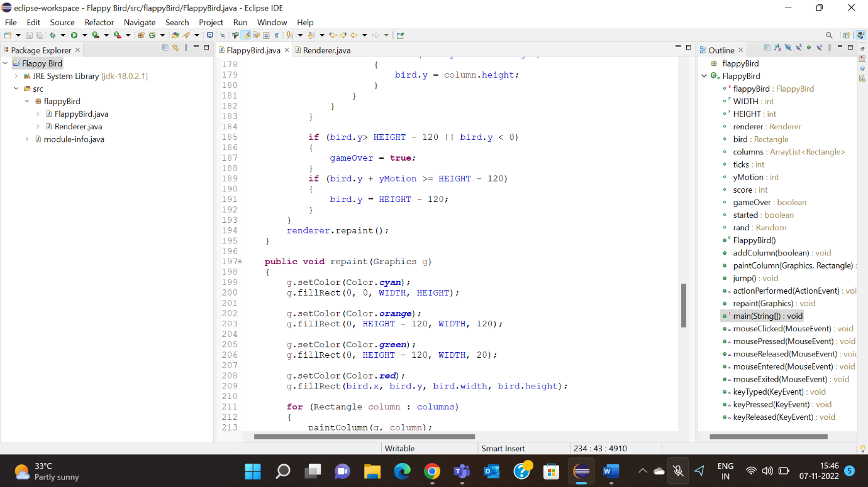

7.

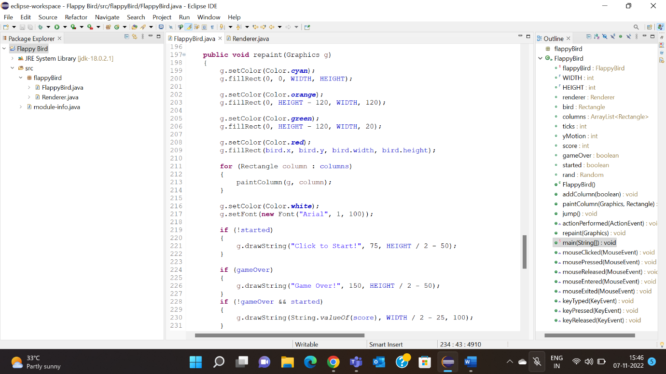

8.

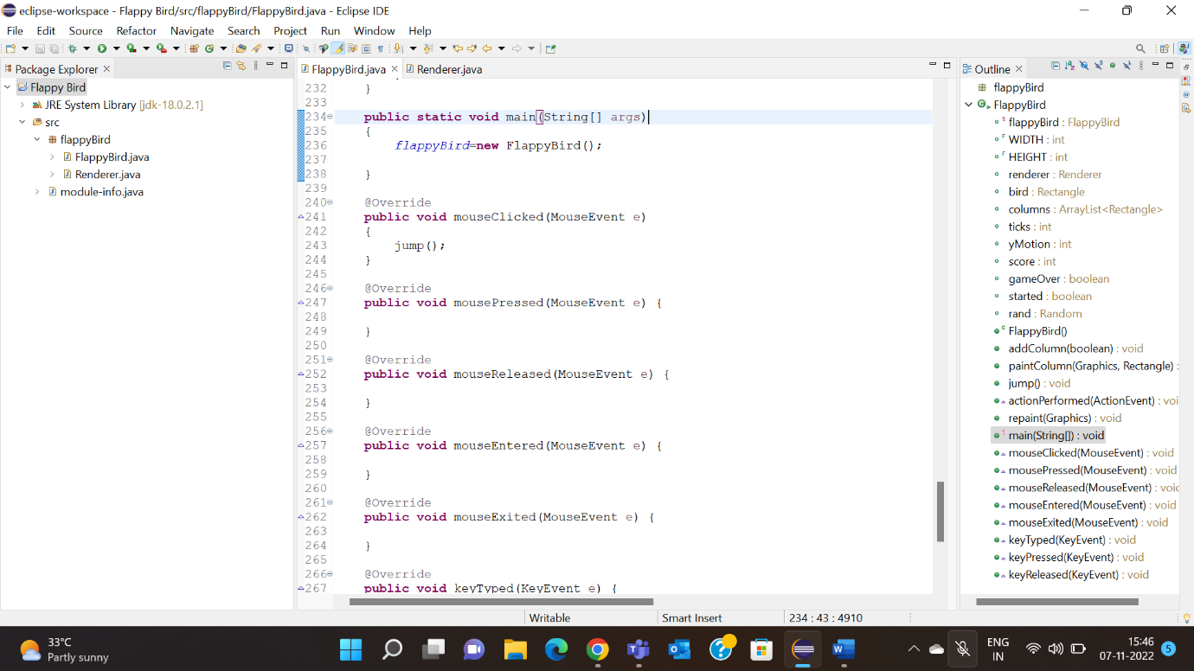

9.

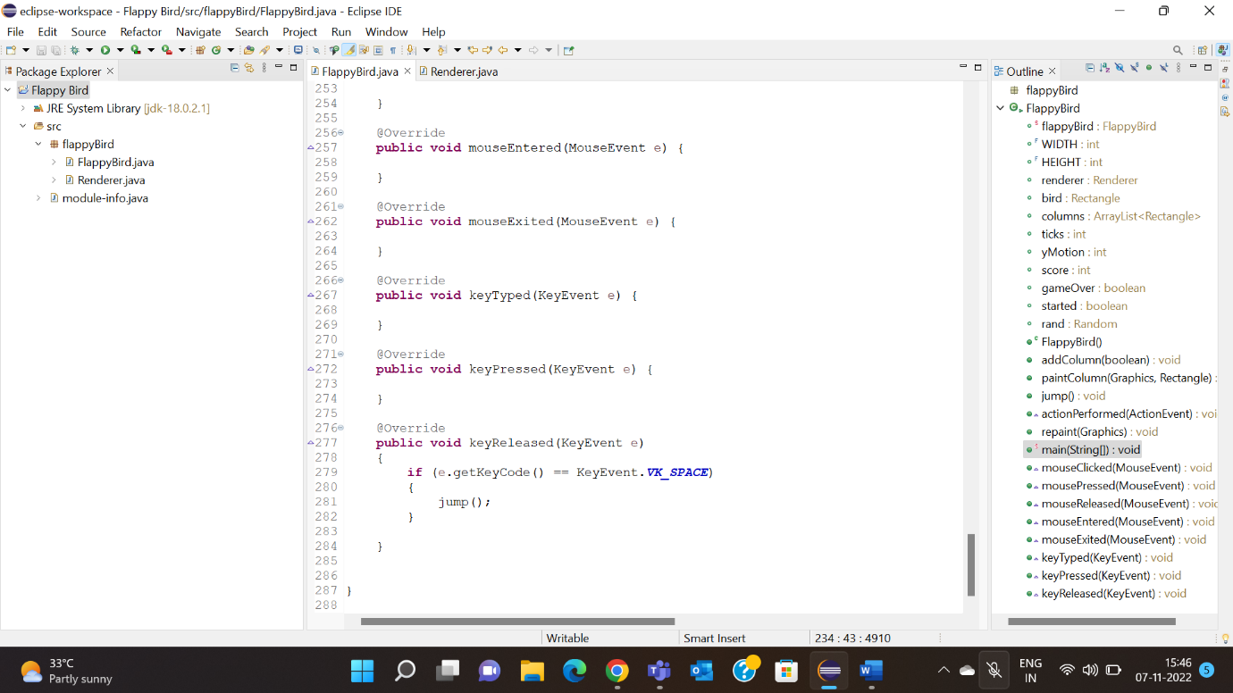

10.

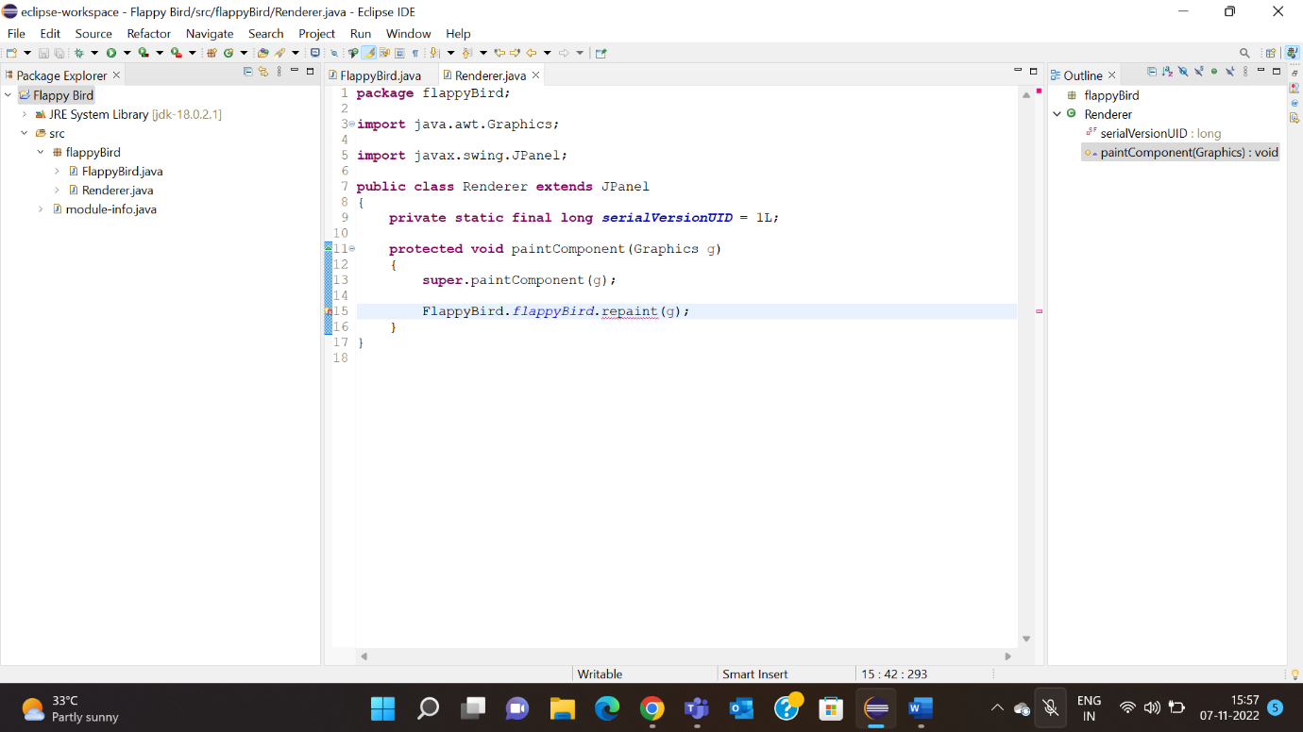

**GAME WINDOW**

